 



Database Programming with SQL 10-3: Multiple-Row Subqueries Practice Activities

# Objectives

* Correctly use the comparison operators IN, ANY, and ALL in multiple-row subqueries
* Describe what happens if a multiple-row subquery returns a null value
* Construct and execute a multiple-row subquery in the WHERE clause or HAVING clause
* Understand when multiple-row subqueries should be used, and when it is safe to use a single- row subquery
* Distinguish between pair-wise and non-pair-wise subqueries
* Create a query using the EXISTS and NOT EXISTS operators to test for returned rows from the subquery

# Try It / Solve It

1. What will be returned by a query if it has a subquery that returns a null ?

Вернет ошибку

1. Write a query that returns jazz and pop songs. Write a multi-row subquery and use the d_songs and d_types tables. Include the id, title, duration, and the artist name.

SELECT id, title, duration, artist

FROM d_songs

WHERE type_code IN ( SELECT code FROM d_types WHERE description IN ('Jazz', 'Pop'));

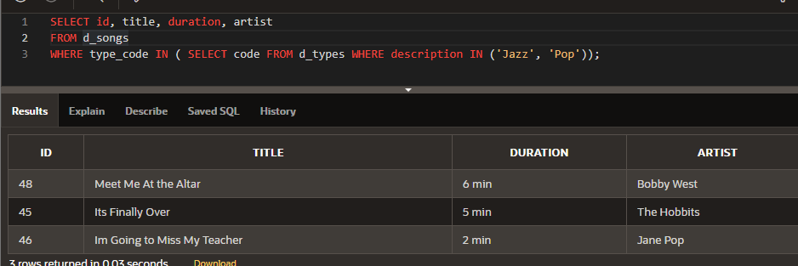

1. Find the last names of all employees whose salaries are the same as the minimum salary for any department.

SELECT last_name

FROM employees

WHERE salary in ( SELECT MIN(salary) FROM employees GROUP BY department_id);

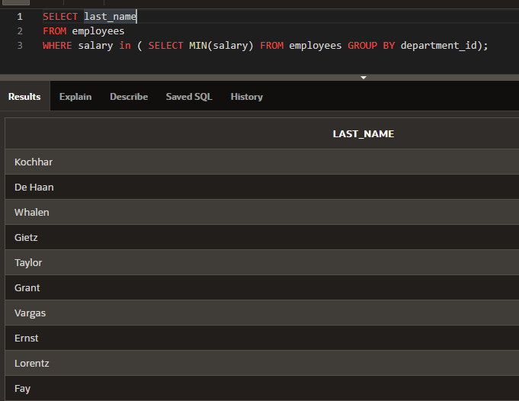

1. Which Global Fast Foods employee earns the lowest salary? Hint: You can use either a single- row or a multiple-row subquery.

SELECT last_name

FROM f_staffs

WHERE NVL(salary,0) = ( SELECT MIN(NVL(salary,0)) FROM f_staffs);

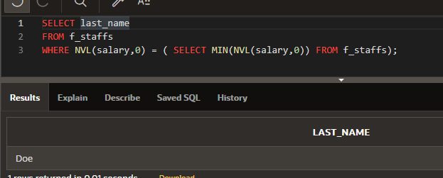

1. Place the correct multiple-row comparison operators in the outer query WHERE clause of each of the following:
   1. Which CDs in our d_cds collection were produced before “Carpe Diem” was produced? WHERE year (SELECT year ...

SELECT *

FROM d_cds

WHERE TO_NUMBER(year) < ( SELECT TO_NUMBER(year) FROM d_cds where title = 'Carpe Diem');

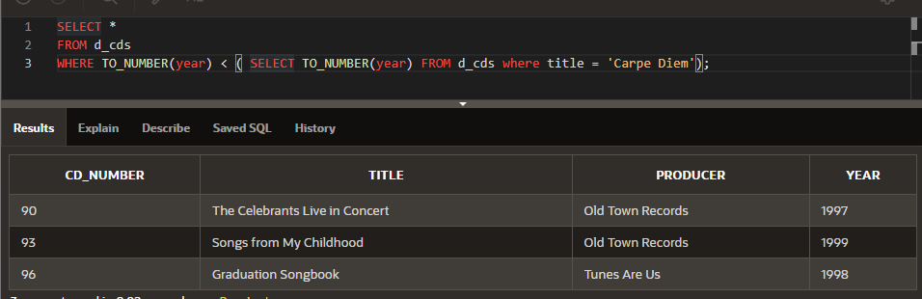

* 1. Which employees have salaries lower than any one of the programmers in the IT department? WHERE salary (SELECT salary ...

SELECT last_name, salary

FROM employees

WHERE salary < ANY ( SELECT salary FROM employees where department_id = (SELECT department_id FROM departments WHERE department_name = 'IT'));

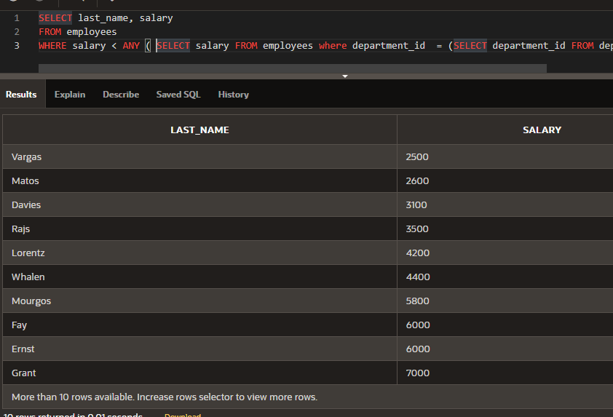

* 1. What CD titles were produced in the same year as “Party Music for All Occasions” or “Carpe Diem”?

WHERE year (SELECT year ...

SELECT title

FROM d_cds

WHERE TO_NUMBER(year) IN ( SELECT TO_NUMBER(year) FROM d_cds where title IN ( 'Carpe Diem', 'Party Music for All Occasions'));

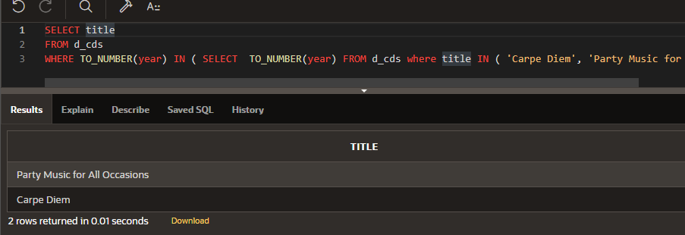

* 1. What song title has a duration longer than every type code 77 title? WHERE duration (SELECT duration ...

SELECT title, duration

FROM d_songs

WHERE TO_NUMBER(REPLACE(duration,' min','')) > ALL ( SELECT TO_NUMBER(REPLACE(duration,' min','')) FROM d_songs where type_code = 77);

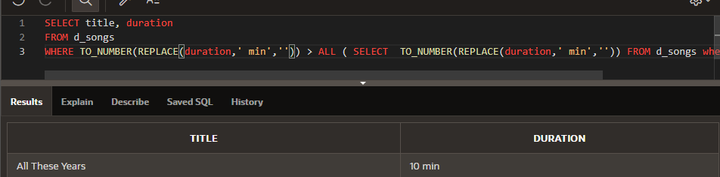

1. If each WHERE clause is from the outer query, which of the following are true?

ПРАВДА a. WHERE size > ANY -- If the inner query returns sizes ranging from 8 to 12, the value 9 could be returned in the outer query.

ЛОЖЬ b. WHERE book_number IN -- If the inner query returns books numbered 102, 105, 437, and 225 then 325 could be returned in the outer query.

ЛОЖЬ c. WHERE score <= ALL -- If the inner query returns the scores 89, 98, 65, and 72, then 82 could be returned in the outer query.

ПРАВДА d. WHERE color NOT IN -- If the inner query returns red, green, blue, black, and then the outer query could return white.

ЛОЖЬ e. WHERE game_date = ANY -- If the inner query returns 05-Jun-1997, 10-Dec-2002, and 2-Jan-2004, then the outer query could return 10-Sep-2002.

1. The goal of the following query is to display the minimum salary for each department whose minimum salary is less than the lowest salary of the employees in department 50. However, the subquery does not execute because it has five errors. Find them, correct them, and run the query.

SELECT department_id FROM employees WHERE MIN(salary) HAVING MIN(salary) > GROUP BY department_id SELECT MIN(salary)

WHERE department_id < 50;

SELECT department_id, MIN(salary)

FROM employees

GROUP BY department_id

HAVING MIN(salary) < (SELECT MIN(salary) FROM employees WHERE department_id = 50);

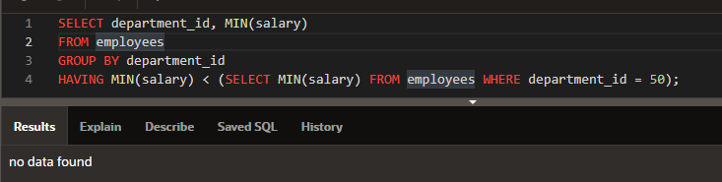

1. Which statements are true about the subquery below?

SELECT employee_id, last_name FROM employees

WHERE salary = (SELECT MIN(salary) FROM employees

GROUP BY department_id);

ЛОЖЬ a. The inner query could be eliminated simply by changing the WHERE clause to WHERE MIN(salary).

ПРАВДА b. The query wants the names of employees who make the same salary as the smallest salary in any department.

ЛОЖЬ c. The query first selects the employee ID and last name, and then compares that to the salaries in every department.

ПРАВДА d. This query will not execute.

1. Write a pair-wise subquery listing the last_name, first_name, department_id, and manager_id for all employees that have the same department_ id and manager_id as employee 141. Exclude employee 141 from the result set.

SELECT last_name, first_name, department_id, manager_id

FROM employees

WHERE (NVL(department_id,-1), NVL(manager_id,-1)) = (SELECT NVL(department_id,-1), NVL(manager_id,-1) FROM employees WHERE employee_id = 141) AND employee_id != 141

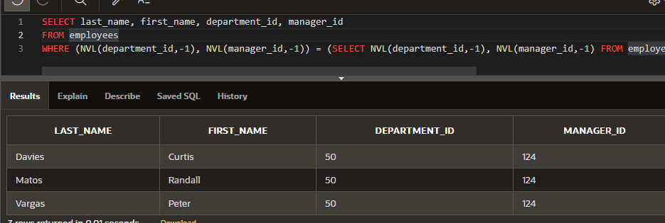

1. Write a non-pair-wise subquery listing the last_name, first_name, department_id, and manager_id for all employees that have the same department_ id and manager_id as employee 141.

SELECT last_name, first_name, department_id, manager_id

FROM employees

WHERE NVL(department_id,-1) = (SELECT NVL(department_id,-1) FROM employees WHERE employee_id = 141)

AND NVL(manager_id,-1) = (SELECT NVL(manager_id,-1) FROM employees WHERE employee_id = 141)

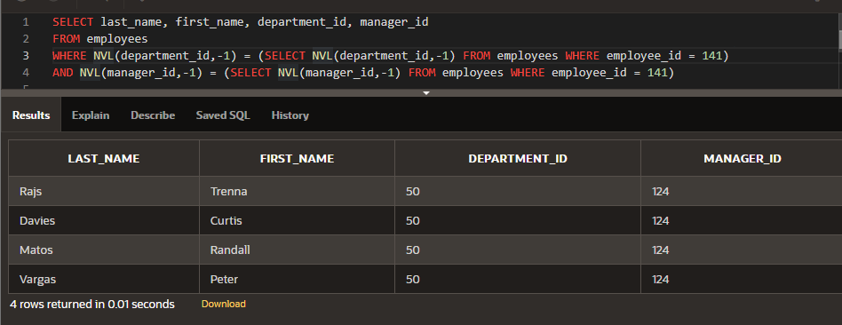

Copyright © 2020, Oracle and/or its affiliates. All rights reserved. Oracle and Java are registered trademarks of Oracle and/or its affiliates. Other names may be trademarks of their respective owners.